**Homework 1: ScroogeCoin**

This homework uses **ScroogeCoin** as an example to practice the content learned in class. The core of the assignment is to complete the writing and testing of the **TxHandler** class. The related runnable project code that I have completed is open source[1], and you can also find the related codes in the attachment folder[2]. I will try to describe the process of completing the homework in as much detail as possible in this report, but I still highly **recommend that the teacher and TA review the code and documentation for more information**!

The following content of this report is organized as follows: first, a detailed analysis of the homework’s **overall requirements and the provided code** is presented; next, **the logic behind writing the relevant code** is clearly described, including the implementation and testing of the class; finally, information about the runtime **environment** and the configuration of the code used in this report is provided.

**1. Overview & Analysis**

The detailed requirements of homework 1 are in the **docs/Homework_1.pdf**: (1) We will implement the logic used by Scrooge to **process transactions and produce the ledger**; (2) Transactions can’t be validated in isolation; it is a tricky problem to choose a subset of transactions that are **together valid**. (3) We will be responsible for **creating** a file called **TxHandler.java** that implements the required API and **testing** it.

This is a cryptocurrency trading process that matches what was taught in class. We need to write the transaction handler to ensure that the transaction is correct. To complete this assignment, we must first analyze **the given class code**:

* ***Transaction.java***: Represents a ScroogeCoin transaction and has inner classes **Transaction.Output** and **Transaction.Input**.
  + Consists of a list of inputs, which have a value and a public key to which it is being paid.
  + Consists of a list of outputs, which have the hash of the transaction that contains the corresponding output, the index of this output in that transaction, and a digital signature. The raw data that is signed is obtained from the **getRawDataToSign(int index)** method.
  + Consists of a unique ID (see the **getRawTx()** method).
  + Contains methods to add and remove an input, add an output, compute digests to sign/hash, add a signature to an input, and compute and store the hash of the transaction once all inputs/outputs/signatures have been added.
* ***Crypto.java***: Verifies a signature, using the **verifySignature()** method.
* ***UTXO.java***: Represents an **unspent transaction output**.
  + A UTXO contains the **hash of the transaction** from which it originates as well as **its index** within that transaction.
  + Includes **equals()**, **hashCode()**, and **compareTo()** functions in UTXO that allow the testing of equality and comparison between two UTXOs based **on their indices and the contents of their txHash arrays**.
* ***UTXOPool.java***: Represents the **current set of outstanding UTXOs**
  + Contains **a map** from each UTXO to its corresponding transaction output.
  + This class contains **constructors** to create a new empty UTXOPool or a **copy** of a given UTXOPool, and methods to **add and remove** UTXOs from the pool, **get the output** corresponding to a given UTXO, **check** if a UTXO is in the pool, and **get a list of all UTXOs** in the pool.

Based on these elements, we need to finish **implementing and testing** the **TxHandler** based on the given framework. Specifically:

* The implementation of **handleTxs()** should return a mutually valid transaction **set of maximal size** (one that **can’t be enlarged simply by adding** more transactions). It need not compute a set of maximum size (one for which there is no larger mutually valid transaction set).
* Based on the transactions it has chosen to accept, **handleTxs()** should also **update its internal UTXOPool** to reflect the current set of unspent transaction outputs, so that future calls to **handleTxs()** and **isValidTx()** are able to correctly process or validate transactions that claim outputs from transactions that were accepted in a previous call to **handleTxs()**.

**2. Implementation & Test**

The runnable result code is in *TxHandler.java* and *TxHandleTest.java*. In this section, I will elaborate on the class **implementation** and **test** code writing logic. The implementation of the **TxHandler** class contains three methods: **TxHandler()**, **isValidTx()**, and **handleTxs()**. The test suite is used to verify the implementation.

**2.1 Details of the implementation**

**Part 1. TxHandler(UTXOPool utxoPool)**

This method is used to create a public ledger with the current UTXOPool being **utxoPool**. So, I defined a private attribute **UTXOPool utxoPool** first. To make a defensive copy of utxoPool, I utilize **new UTXOPool(UTXOPool uPool)** constructor.

public TxHandler(UTXOPool utxoPool) {  
   this.utxoPool = new UTXOPool(utxoPool);  
}

**Part 2. boolean isValidTx(Transaction tx)**

This method is used to verify the validity of the given transaction. It returns true only if the transaction meets the following **5 conditions**:

**(1) All outputs claimed by tx are in the current UTXO pool.** This condition makes sure that all the inputs of the transaction are generated from past transactions' outputs. To implement this, I go through all the inputs of the transaction and check if the utxoPool (created from **TxHandler()**) contains the current input's utxo.

// (1) verify if all outputs claimed by tx are in the current UTXO pool  
if (!utxoPool.contains(curUTXO)) {  
   System.out.println("ERROR (1): The output is not in the current UTXO pool !!");  
   return false;  
}

**(2) The signatures on each input of tx are valid.** This condition makes sure that people who paid the money is the money's owner. To implement this, I go through all the inputs of the transaction and check if all the inputs' **publickey**, **message** and **signature** can match.

// (2) verify the signature on each input of tx is valid  
if (!Crypto.verifySignature(preOutput.address, tx.getRawDataToSign(i), curInput.signature)) {  
   System.out.println("ERROR (2): The input's signature is invalid !!");  
   return false;  
}

**(3) No UTXO is claimed multiple times by tx.** This condition makes sure that there is no double spending in the given transaction. To implement this, for a certain input, I go through all the inputs after it to see if there is any input using the same UTXO with it.

// (3) ensure no UTXO is claimed multiple times by tx  
if (spentUTXOs.contains(curUTXO)) {  
   System.out.println("ERROR (3): Multiple claim of one UTXO !!");  
   return false;  
} else {  
       spentUTXOs.add(curUTXO);  
}

**(4) All of tx's output values are non-negative.** This condition is easy to understand because nobody will spend the negative value of money. To implement this, I go through all the outputs and check if their output value is non-negative.

// (4) ensure all of tx's output values are non-negative  
if (tx.getOutput(o).value < 0) {  
   System.out.println("ERROR (4): The output's value is negative !!");  
   return false;  
}

**(5) The sum of tx's input values is greater than or equal to the sum of its output values.** This condition is also easy to understand because, except for coinbase transactions, no paycoins transactions will have output values larger than the input values. To implement this, I go through all the outputs and outputs and sum the values of inputs and outputs, respectively.

// (5) ensure the sum of tx's input values is greater than or equal to the sum of its output values  
if (inputsTotalValues < outputsTotalValues) {  
   System.out.println("ERROR (5): inputsTotalValues < outputsTotalValues !!");  
   return false;  
}

**Part 3. Transaction[] handleTxs(Transaction[] possibleTxs)**

Given an **unordered** array of proposed transactions, this method can check each transaction for correctness and then return a mutually valid array of accepted transactions, updating the current UTXO pool as well.



**Figure 1.** The example of transactions.

Considering the input array is unorder, some transactions may be valid due to other transactions' confirmation. So, I go through all the transactions over and over again until no valid transactions can be found. If there are valid transactions, update the utxopool. This could be kind of inefficient, but it can make sure there won't be any mistakes! To implement this, I divide it into three steps:

* *Step 1*. Go through all the transactions over and over again and record whether it has a new valid transaction or not.
* *Step 2*. Check the validity of each transaction using **isValidTx()**. If it is valid, add it into the acceptedTxs and update the UTXOPool: add new valid output & delete the spent utxo.
* *Step 3*. If there is no new valid transactions can be found, stop going through all the transactions. The list acceptedTxs is what we need!

**This is not the end of the analysis**! In the real situation, it is easy to see that it is difficult to deal with double spending without a timestamp because there is no way to tell which of the inputs using the same utxo is valid. As Figure 1. shows, there is no way to determine whether TX2 or TX4 is valid. Therefore, after talking with the TA, an additional assumption is made in this place: **for transactions with the double-spend problem, the one that is processed first is valid, and the one that is processed later is invalid**, which is equivalent to a random selection.

For example, **in Figure 1**: If the processing sequence is [TX1, TX2, TX4, TX3], then the acceptedTxs = [TX1, TX2, TX3]. If the processing sequence is [TX1, TX4, TX2, TX3], then the acceptedTxs = [TX1, TX4].

**2.2 Details of the test suit**

Here, a **full range of black-box tests** need to be performed on the three functions implemented above. Simulating a real transaction between Scrooge, Alice and Bob will be very helpful for testing the functionality. To make things easier, some preparatory work has been done before completing the tests in turn.

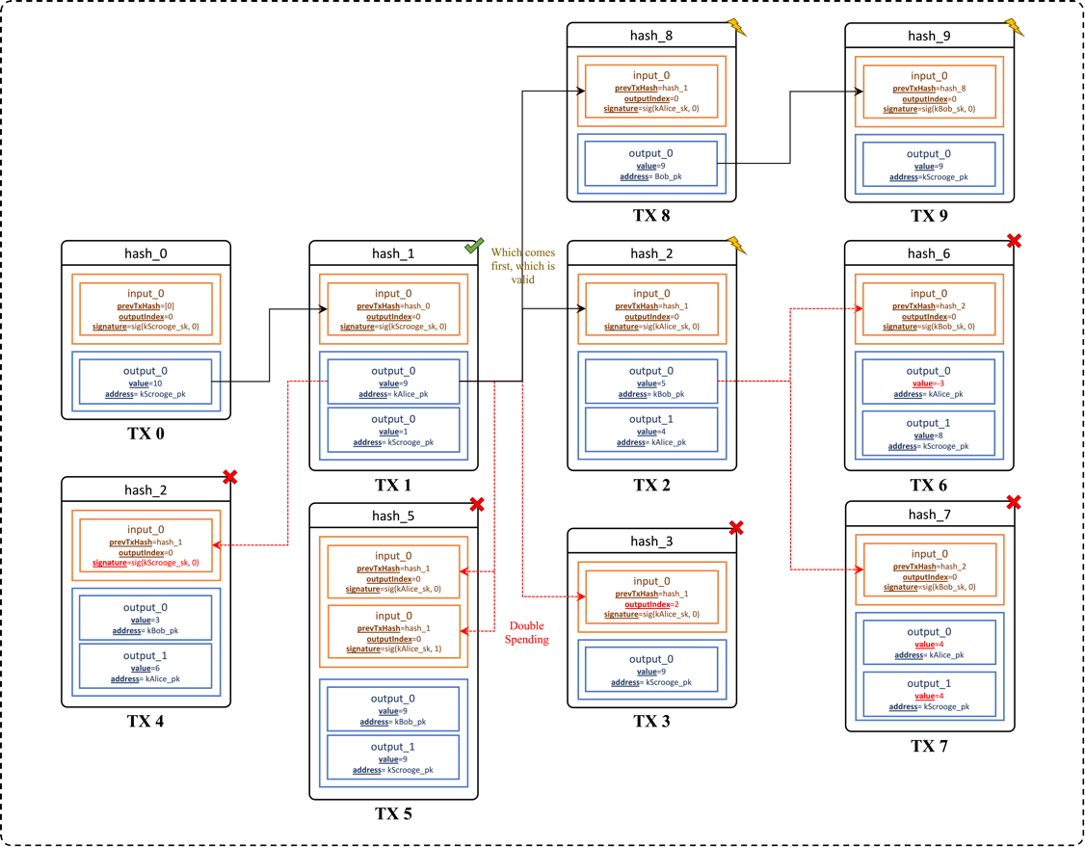

**Figure 2.** The transaction relationship for testing.

**Some preparations for tests @Before**

The original Transaction class did not have a function to sign, which means that it is a question of where the signature in Input comes from. Here, the **signTX()** function is added according to the **verifySignature()** method. I create the coinbase transaction **tx0** and initialize the **UTXOPool**. I also created nine other translations (from **tx1** to **tx9**) between Alice, Bob and Scrooge. Some of them are correct, while others are incorrect. The specific input-output relationships are shown in **Figure 2**.

**Tests for the isValidTx() function**

To present the testing process more clearly, I have made the test table form here. Table 1. shows the details of tests for **isValidTx()** function, including test function, purpose, data, and results.

**Table 1.** The test table for **isValidTx()** function.

| **Test Function** | **Test Purpose** | **Data for testing** | **Expected Result** | **Actual Result** |
| --- | --- | --- | --- | --- |
| test_tx_is_valid() | Test for valid transactions (which meet 5 conditions). | Valid transaction tx1. | True | True |
| test_tx_input_not_in  _utxoPoo1() | Test for UTXO not being containing in UTXOPool because the previous transaction hasn't happened. | Transaction tx2 before and after transaction tx1 being handled. | Before False After True | Before False After True |
| test_tx_input_not_in  _utxoPool2() | Test for UTXO not being contained in UTXOPool because of pointing the wrong previous transaction's index of outpout. | Transaction tx3 with correct previous transaction tx1 's hashValue but wrong index. | False | False |
| test_tx_input_with_  wrong_signature() | Test for transaction with wrong signature. | Transaction tx4 with wrong signature | False | False |
| test_utxo_is_claimed_  multiple_times() | Test for no UTXO is claimed multiple times. | Transaction tx5 with double spending. | False | False |
| test_tx_output_with_  negative_values() | Test for all of transactions' output values are non-negative. | Transaction tx6 with negative values of outputs even though the total amount of outputs less than the total inputs. | False | False |
| text_tx_outputValue_  larger_than_inputValue() | Test for the sum of transactions' input values is greater than or equal to the sum of its output values. | Transaction tx7 with output > input even though each output amount is less than the total inputs. | False | False |

Note that all the testing data with certain deficiencies can become valid transactions only if we fix the deficiencies. This can ensure that the data for testing are suitable for the certain circumstances we want.

**Tests for the handleTxs() function**

To present the testing process more clearly, I have also made Table 2. I strongly recommend that you refer to Figure 2. for the observations made here!

**Table 1.** The test table for **handleTxs()** function.

| **Test Function** | **Test Purpose** | **Data for testing** | | **Expected Result** | **Actual Result** |
| --- | --- | --- | --- | --- | --- |
| test_handle_  unordered_txs() | Test for an unordered array of proposed transactions (some are valid, and some are invalid). | | {tx3, tx4, tx5, tx6, tx7, tx2, tx1} | {tx1, tx2} | {tx1, tx2} |
| test_handle_  unordered_txs_ds1() | Test the first situation of double spending in different txs. | | {tx2, tx8, tx9, tx1}, where tx2 and tx8 are double-spending | {tx1, tx2} | {tx1, tx2} |
| test_handle_  unordered_txs_ds2 | Test the second situation of double spending in different txs. | | {tx8, tx2, tx9, tx1}, where tx2 and tx8 are double-spending | {tx1, tx8, tx9} | {tx1, tx8, tx9} |

**Test results**

In my PC’s environment (details of which are described below), **all of the above 10 test functions passed**, as shown in Figure 3. This implies that the above function implementation logic and validation ideas are **correct**!

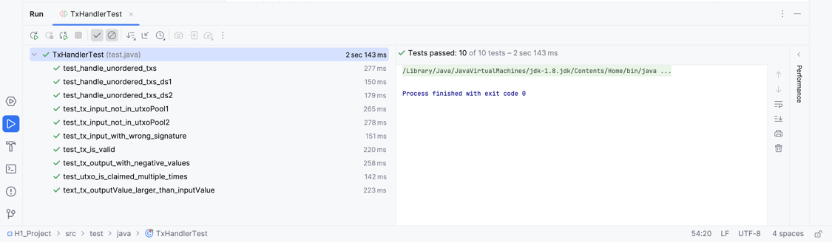

**Figure 3.** The test results in my PC.

**3. Environment**

Because JDK versions are updated so quickly, there are a lot of things in the old code that will be wrong in the new JDK version, such as the **finalize()** function. It is highly recommended to **install Java 8 instead of the latest version of the JDK**.

All of the code in this repo is run on the **MacOS (M2)** with **JDK1.8,** [**junit-4.13.2**](https://repo1.maven.org/maven2/junit/junit/4.13.2/junit-4.13.2.jar) **and** [**hamcrest-1.3**](https://repo1.maven.org/maven2/org/hamcrest/hamcrest-all/1.3/hamcrest-all-1.3.jar). Just download the **.jar** files and use the **file => project** **structure** to organize them.

To demonstrate the reproducibility of the results, I built a CI tool using GitHub Actions to run the test code online and show the results. Figure 4. shows the results from the CI[3], and again, it passes all the tests!

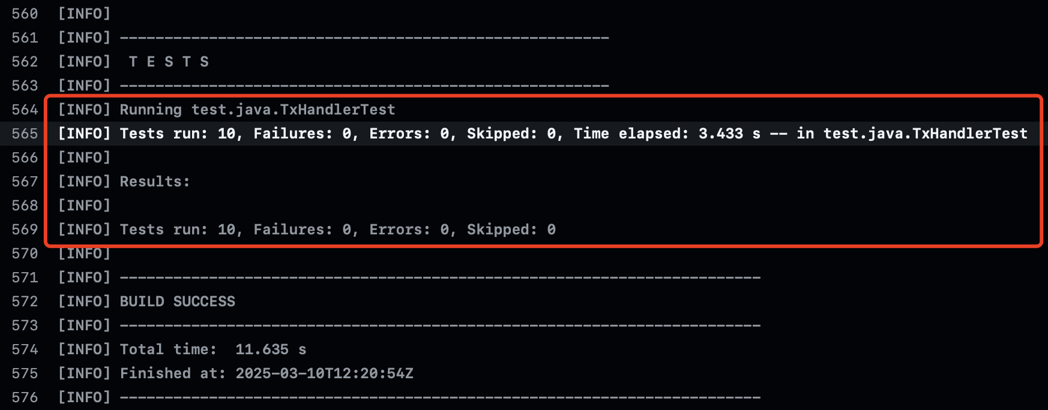

**Figure 4.** The test results in CI of GitHub Actions.

1. <https://github.com/KarryRen/BC-and-DC/tree/main/Homeworks/Homework_1/H1_Project>
2. The implementation code of the **TxHandler** is in *src/main/java/TxHandler.java* and the test code is in *src/main/test/TxHandlerTest.java*.
3. Can be found at:

   https://github.com/KarryRen/BC-and-DC/actions/runs/13764485375/job/38487708521#step:4:566